**Nome:** Ruan Campos Silva 3 ADS Tarde

Exercicio 1

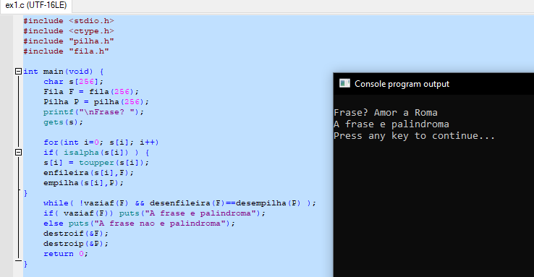

Exercicio 2

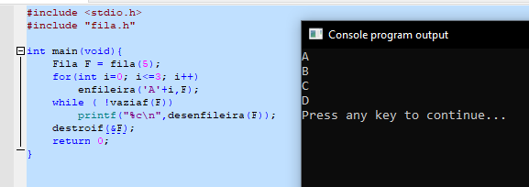

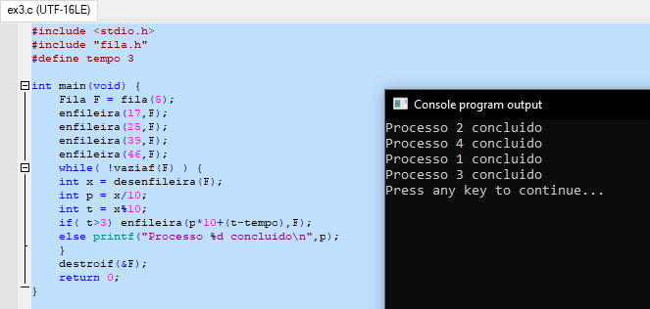Exercicio 3